**Fatigue Timer**

***C:\Users\Public\Documents\LabVIEW Fatigue Vis\Fatigue Test Timer***

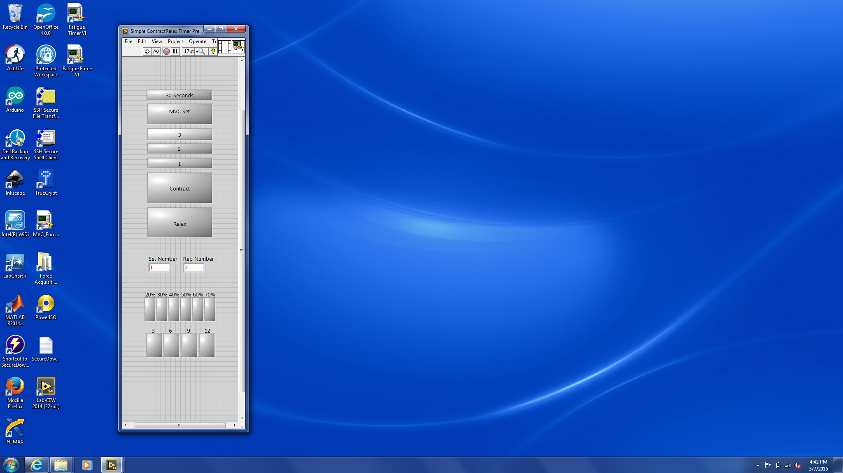

Post MVC Contraction Indicator Lights

Fatigue Submax Set Indicator Lights

Set Number – Displays the current set (20%, 30%, etc.)

Rep Number – Displays the current contraction count

Indicator Lights:

30 Seconds! – Used for Post Fatigue MVCs, goes off 30 seconds prior to the MVC, single beep

MVC Set – Lights up for each MVC set

3, 2, 1 – Count down for contractions (duration of each is 1 second)

Contract – Lights up and beeps indicating time to contract (duration 4 seconds)

Relax – Lights up and beeps indicating time to relax (duration 3 seconds + 3 seconds in 3, 2, 1 countdown

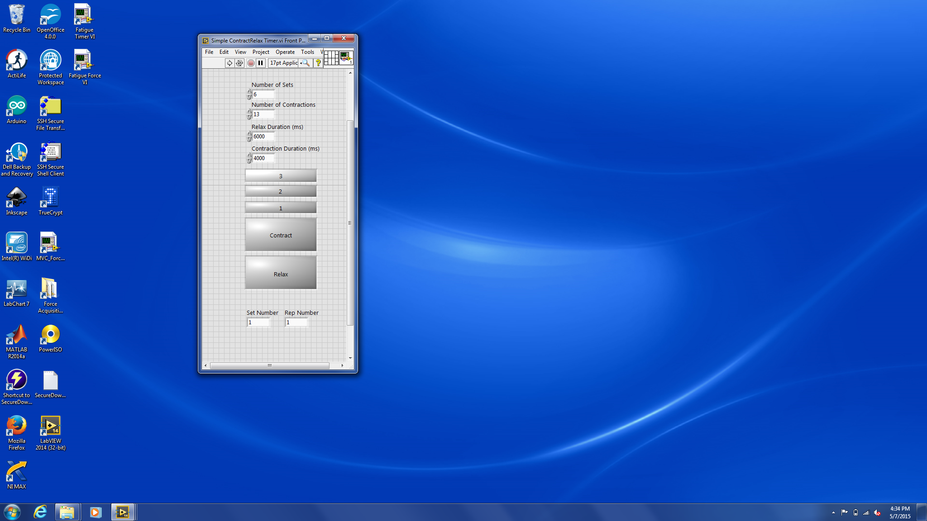

**Contract/Relax Timer**

***C:\Users\Public\Documents\LabVIEW Fatigue Vis\Simple ContractRelax Timer***

Indicator Lights:

3, 2, 1 – Count down for contractions (duration of each is 1 second)

Contract – Lights up and beeps indicating time to contract (duration 4 seconds)

Relax – Lights up and beeps indicating time to relax (duration 3 seconds + 3 seconds in 3, 2, 1 countdown

Set Number – Displays the current set (20%, 30%, etc.)

Rep Number – Displays the current contraction count

Controls:

Number of Sets – Enter in total number of sets

Number of Contractions – Enter in total number of contractions per set

Relax Duration – Enter relax duration (ms), 3 seconds will be subtracted to account for 3, 2, 1 countdown so relax duration must be at least 3 seconds

Contraction Duration – Enter in contraction duration (ms)